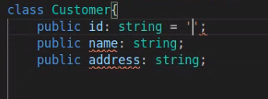

errors, because no initial values assigned

solution:- create class like
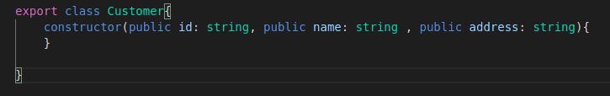

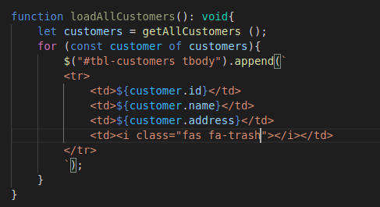

payload = body = form data

Cross Origin Resource Sharing

safe / non safe

courser errors to AjaX requests under coarse policy
